NAME: K Yamini
REG NO: 192572181

Write a Prolog Program for PLANETS DB.
Aim:
To create a Prolog database of planets and retrieve information about planets using Prolog queries.
Algorithm:
- Start the program.
- Create facts for different planets.
- Store the planet name, type, and position from the Sun.
- Define predicates to retrieve planet information.
- Use a Prolog query to search for a particular planet.
- Prolog matches the query with the stored facts.
- Display the required planet information.
- Stop the program.
Prolog program:
% EXPERIMENT 20
% PLANETS DATABASE

% Planet facts
planet(mercury, inner, 1).
planet(venus, inner, 2).
planet(earth, inner, 3).
planet(mars, inner, 4).
planet(jupiter, outer, 5).
planet(saturn, outer, 6).
planet(uranus, outer, 7).
planet(neptune, outer, 8).

% Display planet information
show_planet(Name) :-
planet(Name, Type, Position),
write('Planet: '),
write(Name),
nl,
write('Type: '),
write(Type),
nl,
write('Position from Sun: '),
write(Position),
nl.

% Find all inner planets
inner_planet(Name) :-
planet(Name, inner, _).
Input:
?- show_planet(earth).
Output :
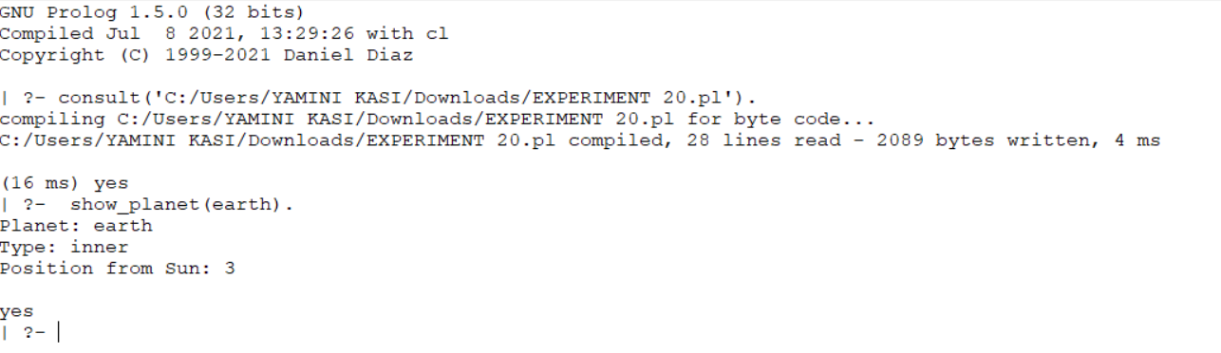

Result:
Thus, the Prolog program for the Planets Database was successfully implemented and the required planet information was retrieved using Prolog queries.

